Ideation Phase
Define the Problem Statements

Date | 5/7/2026
Team | Edralla Roja  Reddy Anusha
Project Name | Strategic product placement analysis: unveiling sales impact with tableau visualization

Customer Problem Statement Template: 1. The Customer Who is the customer?

The primary customers are Retail Store Managers, Category Analysts, and Merchandising Directors who manage physical store layouts.
What is the customer's goal?
To maximize revenue per square foot by ensuring high-margin products are placed in the most visible and accessible locations for shoppers.

- The Problem What is the problem?

There is a significant "Visibility Gap." Stakeholders know what is selling, but they don't have a visual way to see where it is selling best within the store.
When does the problem occur?
This occurs during Shelf Planning (Plannogramming) and Monthly Sales Reviews when managers try to figure out why certain high-quality products are underperforming.
Where does the problem occur?
On the retail floor—specifically in "Dead Zones" (corners or bottom shelves) that receive high foot traffic but low sales conversion.

- The Impact
How does it affect the customer?
Without spatial data, managers make "gut-feeling" decisions. This leads to Revenue Leakage, where expensive floor space is wasted on low-margin items while premium products remain hidden.
What is the negative outcome?
Lower "Average Basket Value" because customers aren't being guided toward complementary or impulsebuy products through strategic placement.

- The Ideal State

What is the desired outcome?

An Interactive Tableau Dashboard that overlays transaction data onto a 2D store map.

How will this help?

Managers will be able to "see" the sales impact of moving a product from a bottom shelf to eye level, allowing them to transform low-performing aisles into high-profit zones.

- Problem Statement Summary

"Retail Managers are currently struggling to quantify the financial impact of product positioning. Because they lack visual analytics, they are unable to identify 'Dead
Zones' on the floor. Our project solves this by using Tableau Visualization to map sales data to physical locations, enabling data-driven placement that increases overall store profitability.”

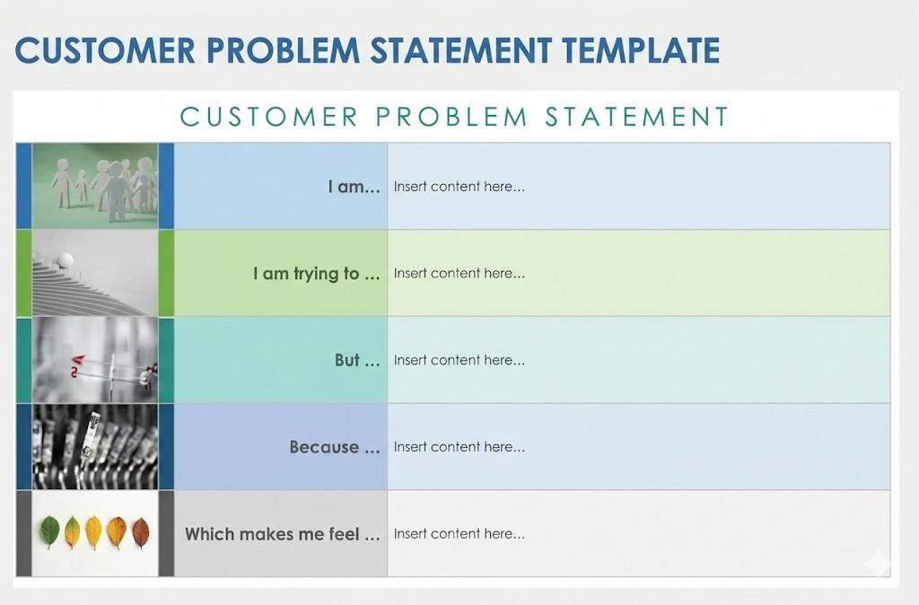

Example
Component Project-Specific Matter
I am a: Retail Store Manager or Category Analyst responsible for maximizing store revenue and managing shelf inventory.

I’m trying to Optimize product placement on shelves and within store zones to increase sales of high-margin items.

But I lack visual data to see which specific locations (eye-level vs. bottom shelf) or store zones are "dead zones" vs. "hot spots".

Because Current sales reports only show what sold, not where it sold, making it difficult to quantify the spatial impact on consumer behavior.

Which makes me feel Frustrated and uncertain about whether the current store layout is actually maximizing potential profit.

